# LINEAR REGRESSION WITH MULTIPLE VARIABLES

## ~~Environment Setup Instructions~~

## Multivariate Linear Regression

Multiple Features

* … or variables



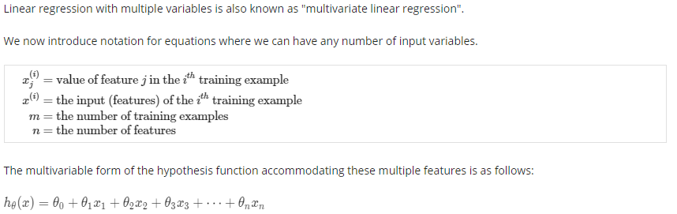

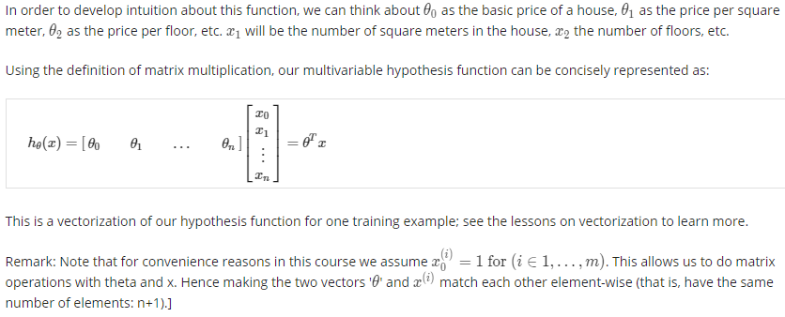

Gradient Descent for Multiple Variables

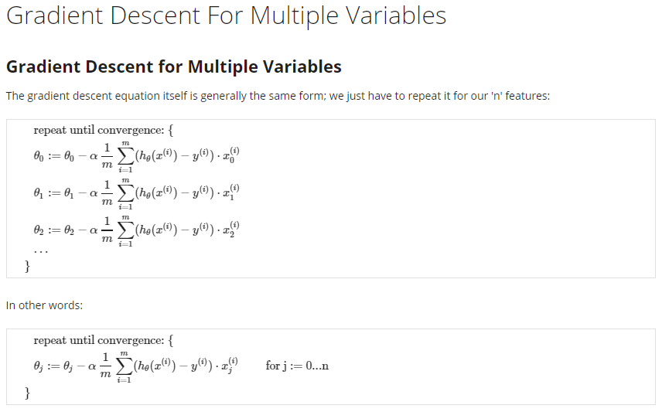

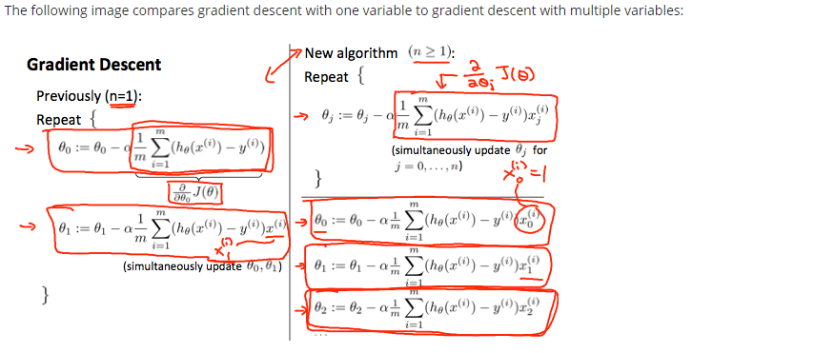

Gradient Descent in Practice I – Feature Scaling

* Feature scaling
* (-) 3 and (-) 1/3
* Mean normalization



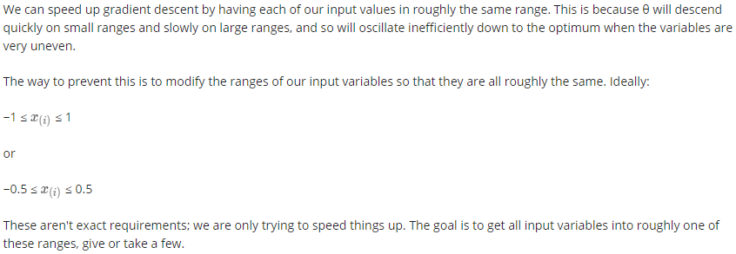

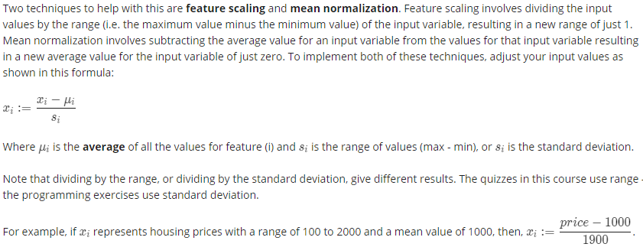

Gradient Descent in Practice II – Learning Rate

* Debugging
* Selection



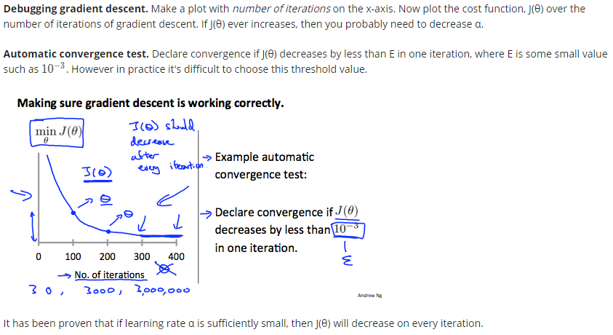

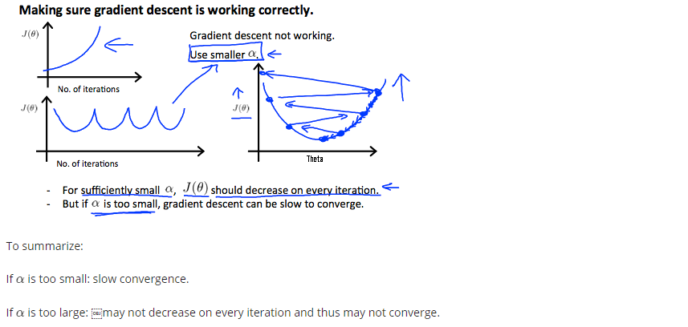

Features and Polynomial Regression

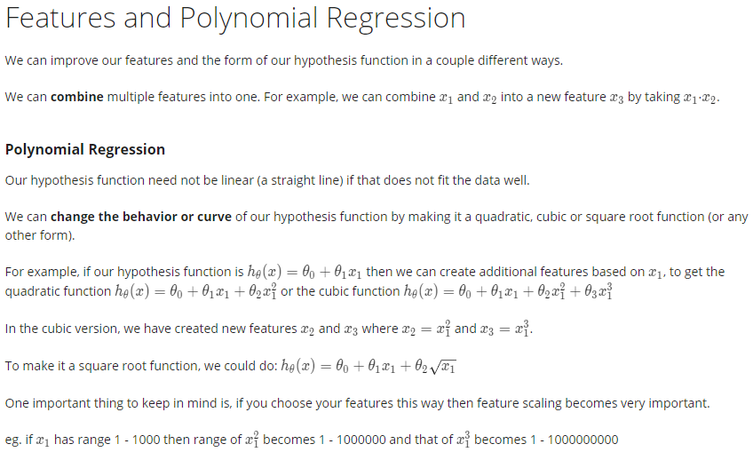

## Computing Parameters Analytically

Normal Equation

* Analytical solution
* Classification (logistic regression) algorithms – example of complex algorithms



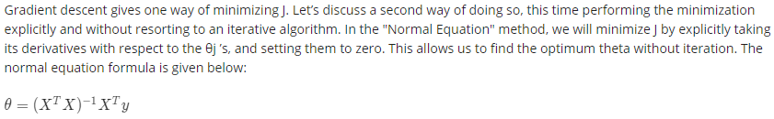

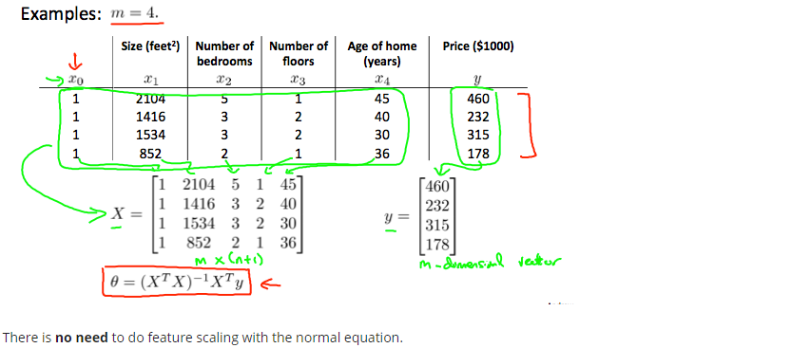

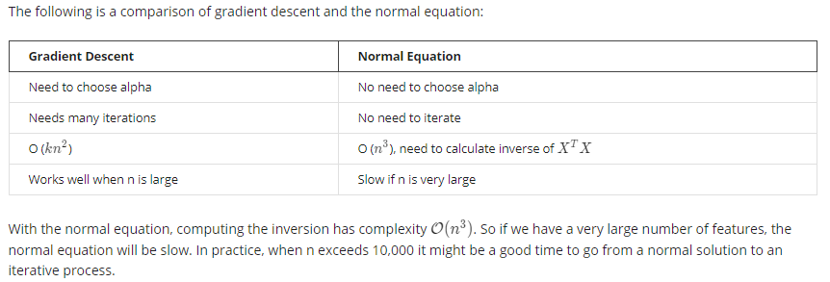

Normal Equation Noninvertibility

* Regularization

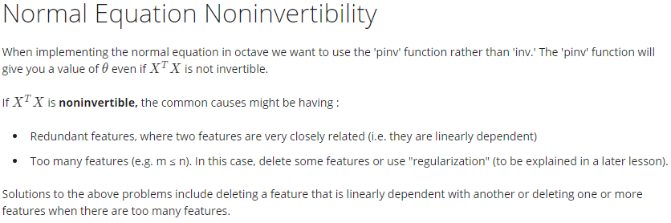

## Submitting Programming Assignments

Working on and Submitting Programming Assignments

* Steps
* email address, submission password

Programming Tips From Mentors

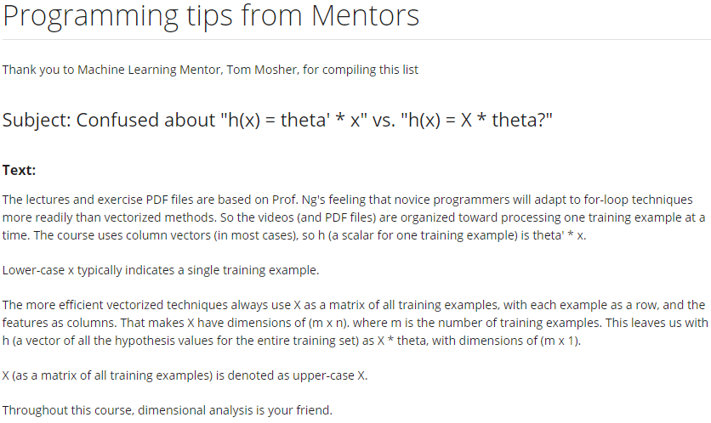

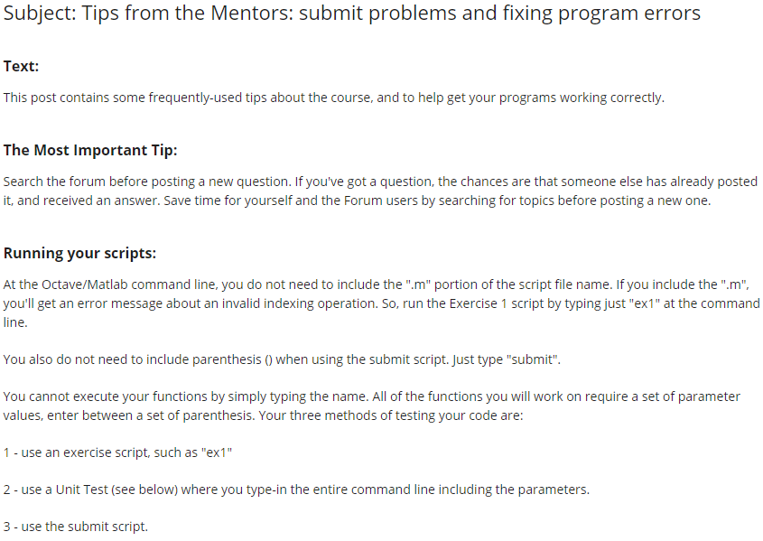

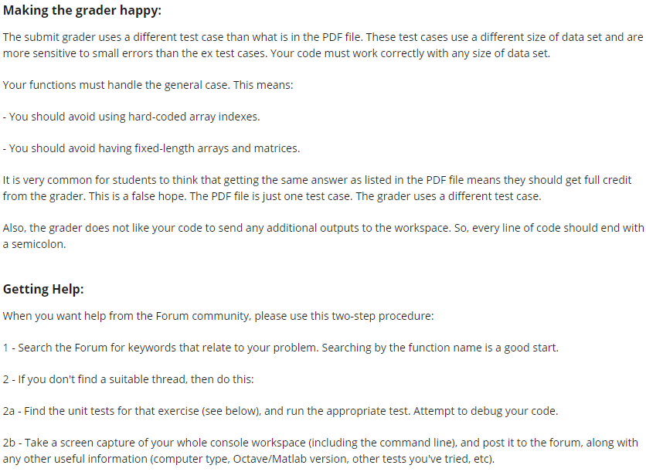

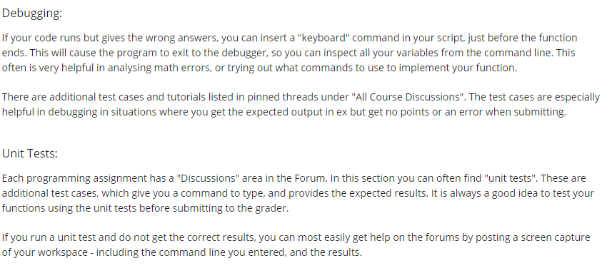

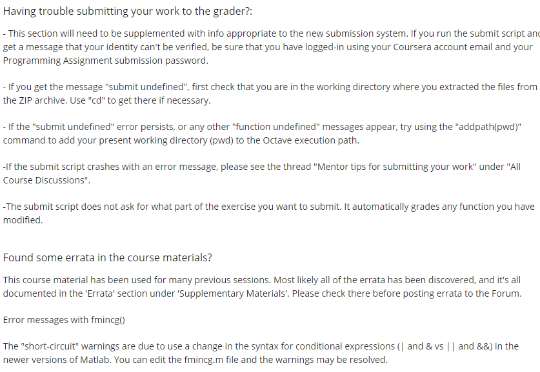



<https://octave.org/doc/v5.2.0/Broadcasting.html>

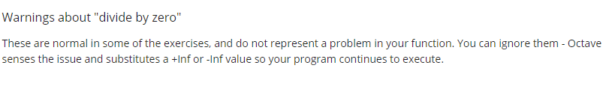

# OCTAVE/MATLAB TUTORIAL